OPSC7312

Azhar Anath: ST10083667

Malekah Aaliah Luther : ST10142592

Ayush Rajcoomar : ST10074013

Avarn Sewlal : ST10083252

OPSC7312: Part 1

Open Source Coding (Intermediate)

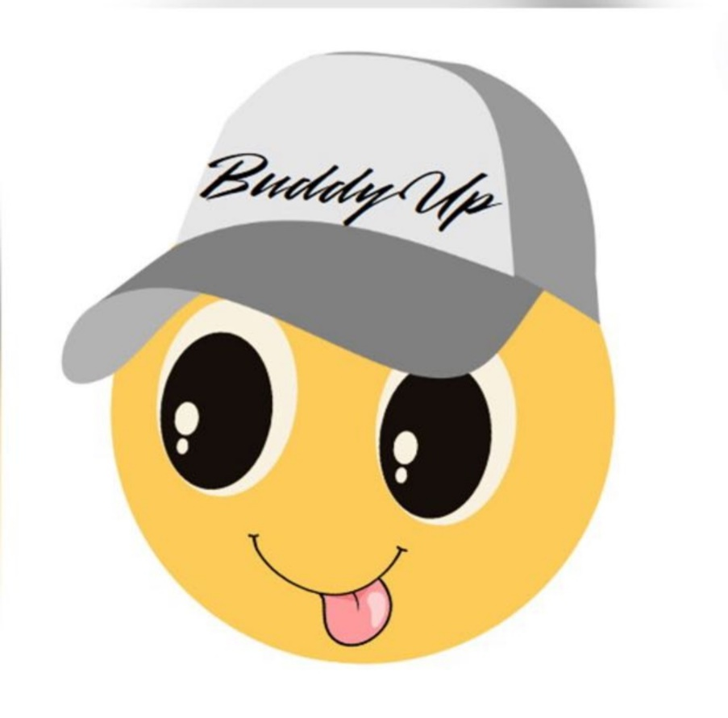

## Write Up AI Tools in Implementing the Virtual Pet Application

The development of our virtual pet application leveraged a variety of AI-powered tools to streamline the design, research, and presentation processes. These tools were integral in bringing our vision to life, ensuring that the final product was both visually appealing and well-structured. Below is a breakdown of how each AI tool contributed to the implementation of key features in the project:

## Canva – Logo Design

Canva, a popular graphic design platform, was employed to create the logo for the virtual pet application. With its AI-driven design suggestions and easy-to-use interface, Canva allowed us to experiment with various design elements quickly. The platform’s extensive library of templates, icons, and fonts, enhanced by AI recommendations, helped us craft a logo that is not only visually appealing but also resonates with the theme of the application. The AI-powered design tools in Canva ensured that the logo met the necessary branding standards, offering suggestions on colour schemes, typography, and layout that aligned with modern design trends. The final logo, created with Canva, effectively represents the app’s friendly and interactive nature, contributing to a strong brand identity.

## Figma – Mock-Ups and Prototyping

For designing the user interface and creating interactive mock-ups, Figma was the tool of choice. Figma’s AI-enhanced design features made it easier to create a cohesive and user-friendly interface. The tool’s real-time collaboration features allowed team members to work simultaneously on the project, ensuring that design iterations were quickly implemented. The AI within Figma aids in generating layout suggestions and optimizing the user experience by analyzing design patterns and providing feedback. This capability was crucial in refining the app's navigation and ensuring that the interface was intuitive for users. The mock-ups created in Figma were then used to guide the development team, providing a clear visual representation of the app's design and flow.

## Meta AI – Model Visualization

Meta AI was utilized to generate a comprehensive image of the entire model, providing a clear and detailed visualization of the app's architecture and user interactions. This AI tool was essential in mapping out the various components of the application, from user authentication to AI-driven pet interactions. Meta AI’s ability to create high-quality visualizations of complex models allowed us to better understand the relationships between different system components. This was particularly useful in the planning phase, where having a visual representation of the entire model helped in identifying potential bottlenecks and optimizing the architecture for scalability and performance. The model visualization provided by Meta AI also served as a valuable communication tool, enabling stakeholders to grasp the technical aspects of the project easily.

## ChatGPT – Research and Content Development

ChatGPT played a pivotal role in the research and content development stages of the project. This AI tool was used to gather information on market trends, competitive analysis, and best practices in app development. By leveraging ChatGPT, we were able to quickly compile relevant data and insights that informed our design and development decisions. Additionally, ChatGPT was instrumental in generating content for project documentation, including writing detailed descriptions of features, drafting user manuals, and creating marketing materials. The AI’s ability to produce coherent and contextually appropriate text made it an invaluable resource throughout the project, ensuring that all written materials were clear, concise, and aligned with the project’s goals.

## Conclusion

The integration of AI tools like Canva, Figma, Meta AI, and ChatGPT significantly enhanced the efficiency and quality of the virtual pet application development process. These tools not only expedited the design and research phases but also ensured that the final product was well-structured, visually appealing, and aligned with user needs. By leveraging AI in these key areas, we were able to bring our project to fruition more effectively, delivering a high-quality application that stands out in the competitive virtual pet market.